**Albuquerque, New Mexico**

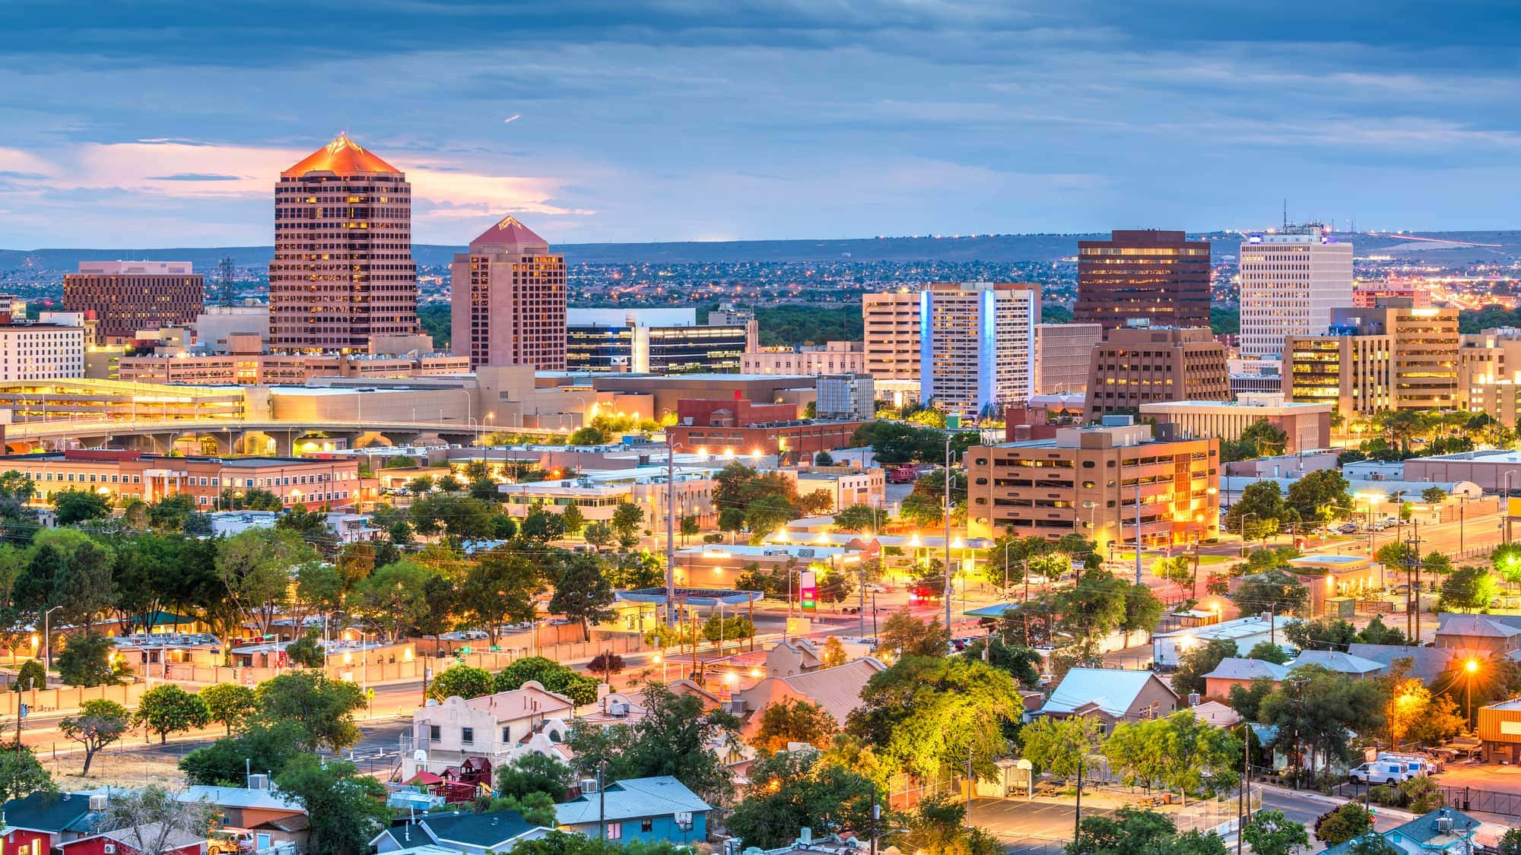

I am super excited to talk about Albuquerque, New Mexico as my geographical location for this discussion board. It is the setting of two shows that I just finished watching, Breaking Bad and Better Call Saul, which made it a great location to study since it is fresh on my mind, and I plan to travel there one day to sight-see!

Located in Bernalillo County, New Mexico, Albuquerque sits at an elevation of 5,312 feet, making it the tallest metropolitan city in the US. Albuquerque was founded in 1706 as a Mexican outpost and incorporated into a city in 1891, years after the railroad’s arrival across the US. 50% of Albuquerque’s population is Hispanic, with the other 50% being held by other races, substantially Caucasians at 38% Non-Hispanic and 17% Hispanic. It’s neighbors include Los Lunas, Bernalillo, Rio Rancho, as well as North and South Valley. Other notable cities that are close to Albuquerque are El Paso, TX, and Sante Fe, NM.

English is the most dominant language spoken in Albuquerque, followed by Spanish and Navajo. Roman Catholicism is the most popular religion alongside other denominations of Christianity. There are also communities of Sikh, Buddhist, and Muslim followers. The cities culture draws greatly from Hispanic and Native American practices, reflected in the arts, architecture, and cuisine of the region. The music culture of the city is notably inspired by Hispanic cultures and genres such as flamingo and mariachi. Located in North America, Albuquerque is a landlocked city that sits in the high desert of the southwest. Its terrains include mesas, arid scrublands, and foothills that reflect its desert-like biome.

Its relative location is in the central part of New Mexico, nestled along the Rio Grande River. To the east of the city you’ll find the Sandia-Manzano Mountains and to the west sits the West Mesa. Its absolute location is 35.0844°N, 106.6504°W, and it lies above the equator in the northern hemisphere.

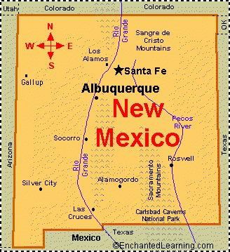

While it is possible to drive from my location of Huntington, WV, to Albuquerque NM by driving U.S. route 60, it would take 24 hours to get there (Talk about a long road trip!). Instead, when I travel to Albuquerque, I will be flying. There aren’t any directs from Huntington, so I would likely fly to Charlotte first, then directly to ABQ. It would be around a 10 Hour flight, which I am willing to do! I would not need to rely on a Mercator map since I would be flying.

In terms of diffusion, we can account for several examples of cultural, linguistic, intellectual, and technological diffusion coming out of Albuquerque. Albuquerque is surrounded by Native American reservations and communities, serving as their main communal and cultural hub. This means the Hispanic culture of Albuquerque bleeds into the Native American communities surrounding it, an example of cultural diffusion. The dialect of New Mexican Spanish has been formulated from years of community between Native American, Hispanic, and Anglo cultures. The combination of these three languages has formulated a unique dialect and language that has spread throughout the surrounding region and can be found in communities in states outside of New Mexico like Texas and California. Intellectual diffusion out of Albuquerque involves the practices of bilingual/multicultural education and technological advancements, specifically in national security and energy conservation. These ideas and practices start with research and patents in Albuquerque that spread with migration and commercialization, leading to both intellectual and technological diffusion across the country.

Albuquerque is a core area in New Mexico, being the largest city in the state and a cultural and economical hub in the southwest. It is an urban community with suburban areas on the outskirts of the city. Due to Albuquerque being the core area of New Mexico, its residents have greater access to education, political representation, developed infrastructure, and better job diversity in contrast to periphery areas like its neighboring cities and towns. This is important to know when comparing Albuquerque to other areas of New Mexico and other major US cities to make inferences about government, education, and culture of the location.

Despite being in the southwestern desert, Albuquerque can have very cold winters and mild summers due to its high elevation. Its climate is classified by the Koppen system as BSk, standing for cold semi-arid climate. With low precipitation, light snow, and lower temperatures for a desert city, Albuquerque makes for one of the mildest climates in the western US.

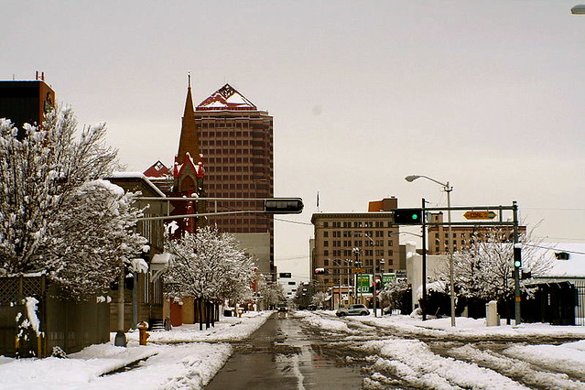

Due to climate change, temperatures have risen, droughts have become more common, erosion has occurred, and water levels have dropped in Albuquerque. Being a city so rich in archeological sites thanks to its long history of Navajo and Hispanic heritage, it is only natural that these things could affect said sites. Erosion, flooding, and extreme heat/UV exposure make it difficult for preservers to maintain these sites as climate change continues to wreak havoc on the world.

Based on the 2024 census, Albuquerque’s population is approximately 560,326 residents. I cannot find an RNI rate for Albuquerque or birth/death rates, but I did find it for New Mexico. As of the most recent study (2023), Albuquerques birth rate is 9.81 per 1,000 people, its death rate is 10.57 per 1,000 people. As such, the RNI would be 9.81 – 10.57 = -0.76 per 1,000 people. It is reasonable to infer that Albuquerque suffers from a similar RNI to its state, indicating a decreasing population in the area. Neighboring cities like Sante Fe and Las Cruces show varying results with RNI’s like -3.0 and +0.7 respectively. These can be attributed to older populations and university-driven towns. Albuquerque is a slowly decreasing and aging city. It is possible that we will see its RNI increase again, but I think it is in a steady spot as it is right now being the most populus city in its state.

I think it is safe to say that Albuquerque is in stage 4 or maybe even 5 of the Demographic Transition Model. Low birthrate, Low deathrate, large and stable population, and high urbanization help us categorize the city into stage 4 of the DTM. Time will tell the future of Albuquerque’s population trends based on immigration, policy decisions on education, and economic opportunity.

That’s all she wrote! I hope you enjoyed taking this adventure to the coldest city in the Land of Enchantment. It has made me want to travel there even more and I am definitely prepared to start planning a trip soon! Here’s one last picture of the annual Hot Air Balloon festival located in Albuquerque, also known as the hot air balloon capital of the world!

